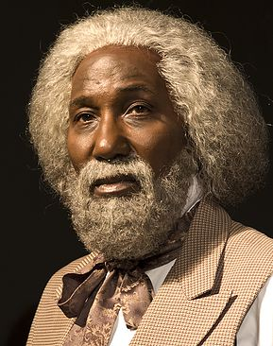
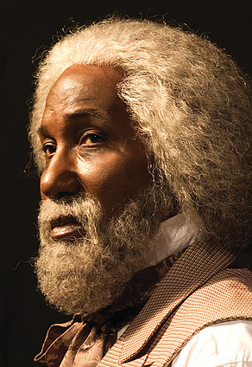

FOR IMMEDIATE RELEASE
(Month Day, Year)

DON’T MISS “Frederick Douglass: In The Shadow of Slavery” PERFORMANCE AT (NAME OF LOCATION)!

Now it is time to watch Frederick Douglass: In the Shadow of Slavery performed at (Name of Venue), located at (Address of Venue), on (Month Day, Year)!

Above the rioting streets of Port au Prince on a hot tropical morning in 1891, Frederick Douglass stands barricaded in his home, unfazed. The former slave, newspaper editor, abolitionist, and current American Ambassador to Haiti, has seen it all. At 73 years old, the most famous black man in the world faces the encroaching violence and reflects on an ambitious career filled with progress and compromise and asks himself the most important question of his life, has there been too little of one and too much of the other?

Frederick Douglass - In the Shadow of Slavery is a highly suspenseful and provocative one-man adventure that barrels headfirst into the dramatic complexities of American history. Experience Douglass’ heartbreaking childhood as a plantation slave and his perilous escape to freedom, marvel at his mastery of the spoken word as he denounces the brutal injustices of slavery. Hear with gripping detail of his uneasy alliance with radical John Brown and of the unwavering friendship he shared with Abraham Lincoln.

For more information, please contact:
(First and Last Name of Contact)
(Name of Contact Company)
(Contact Phone)
(Contact Email)

###

