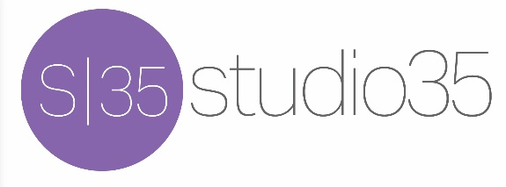

The Bill Berguson Band
Rider 2022-23

Hospitality: Water and assorted soft drinks, fruit and assorted snacks.

Tech Rider: high quality equipment run by a professional sound company. Load-in time of 45 minutes with a minimum of 30 minute sound check. On-stage requirements are as follows:

Bill - front stage right, one vocal microphone, one mic for guitar amp. High quality floor monitor
Mark - front stage left, one vocal microphone, 3 DIs 1/4 inch out for 2 keyboards and one cello, high quality floor monitor
Chris - back stage right, one DI XLR for bass amp, high quality floor monitor
Travis - center stage, standard drum mic setup, High quality floor monitor.

Questions? Contact Bill Berguson 218-349-2239
billbergusonband@gmail.com

