C Street Brass
Hospitality Rider 2022-2023

Lodging
- 5 single rooms at 3+ star hotel OR lump sum determined by band to cover cost of Airbnb

Food and Drink
- Green Room Hospitality:
- One (1) case of bottled spring or purified water
- Light snacks: i.e. fresh fruit, granola bars, chips and salsa, cheese and crackers, etc.
- $20 meal buyout per person ($100 in $20 bills please).

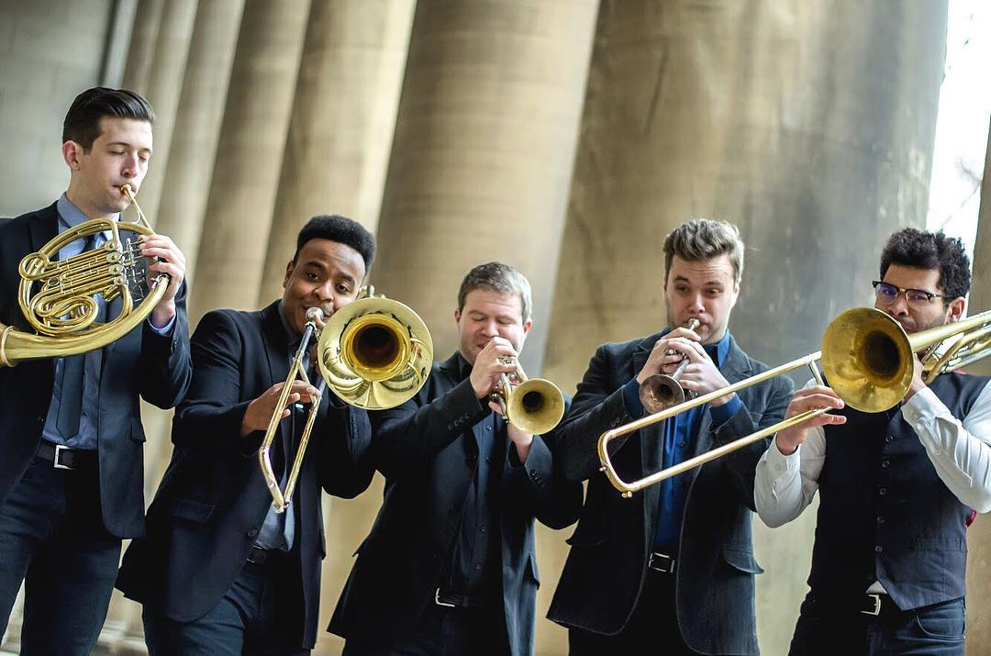

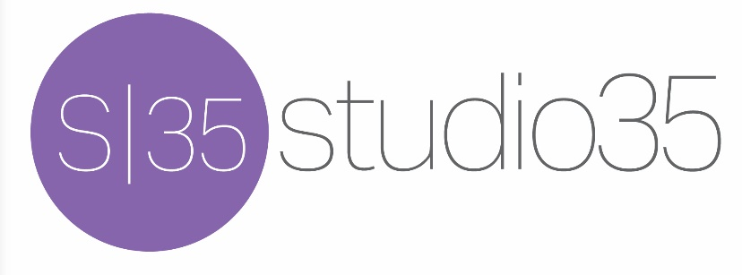

Booking Contact: Sabrina Olson 612.599.8673 .booking@studio35music.com

