ANDREW SALGADO
Technical Rider
Thank you for accommodating us with these details. If you have any questions, please email info@synapsepublishing.com

Contact Information:
P.O. Box 206
Hermitage, TN 37076
Day of Contact: 615-630-9704
Questions 615-920-3690 – Synapse Publishing & Entertainment, LLC

General Information

Sound:

Andrew Salgado will not be bringing any audio equipment to the event. We will require a qualified audio technician to run the sound Please provide an 8’ x 8’ drum riser.

Merchandise :

In an area of the lobby or other suitable place, please provide at least one 8’ table and one volunteer to help oversee the table.

Instruments :

See Stage Plot for equipment layout

1. 22 inch kick
2. 10 inch tom
3. 14 inch floor tom
4. 6.5 x 14 inch snare
5. 3 different 18 inch Zildjian crashes
6. 13 or 14 inch hats
7. 20 inch ride
8. Hardware including 5 cymbal stands and 2 snare stands
9. Remo coated Ambassadors (drumheads) for snare and tom batter
10.Clear Ambassadors for bottom of toms
11.Powerstroke kick drum batter head
12.Ebony kick drumhead

Guitar Amps:

1. Electric guitar amp not required unless a fly event, the 30W minimum tube amp (Fender, Vox, etc.)
2. Bass amp not required unless a fly event, then 500W minimum (MarkBass, Hartke, etc.)

Technical Information

Front of House:

The house sound system must be capable of producing a 20 Hz to 20 kHz frequency range at 115 db SPL on the back row of the venue. Many times, sound systems need to be supplemented by additional power amps, main speakers, and SUB WOOFERS to achieve this requirement. The subs are especially important to us and again, this equipment can be either rented or borrowed. Let us know if you have a problem fulfilling this requirement.

Mixer:

Must have at least 16 channels with XLR inputs, 4 pre-fader auxiliaries, and phantom power. Please have a graphic EQs set up on the mains and monitors at mix position. AS will need separate channels. This may require an extra sound board.

Personnel :

Please have a qualified audio technician present before, during, and after the event. If possible, please provide one person to assist with load in/out.

Monitors:

Andrew Salgado will assist the house engineer and take the band through monitor checks after a line check has been done on all channels. This is the quickest and most efficient way for us to do monitors.

We will need
Monitor 1: Andrew Salgado (Mix = Lead Vocal / Acoustic Guitar/ Electric guitar)
Monitor 2: Bassist (Mix = Lead Vocal / Acoustic Guitar/ Electric guitar)
Monitor 3: Drummer (Mix = Lead Vocal / Acoustic Guitar/ Electric guitar/Bass)

Technical Information (continued)

Input List

(You are free to set inputs however you like, but this seems to work best. Please refer to stage plot for placement)

1. Vox (Andrew Salgado)
2. Acoustic Guitar - Andrew (direct out – XLR )
3.Bass Guitar (direct out - XLR)
4. Electric Guitar (direct out - XLR)
6. -OPEN -
7. Kick
8. Snare
9. High Hat
10. Rack Tom
11. Floor Tom
12. Overhead SR
13. Overhead SL
14. Ride Cymbal
15. –OPEN-
16. -OPEN -

Hotel Accommodations:
We will need 2 hotel rooms with at least 2 double beds for Sunday Night 8/22 arrival. Please have the room keys available for the tour manager before the event ends. We will also need a green room – preferably private, at the venue to prepare for the event. Please be sure Wi-Fi or internet access is available.

Meals:

While at the event, if greater than 2 hours – healthy snacks (fruit/veggies/granola bars or meal and bottled water should be made available for the band – 3 people.

Thank you for your time and consideration in this matter. We are always grateful for anything that is provided for us. We look forward to seeing you soon!

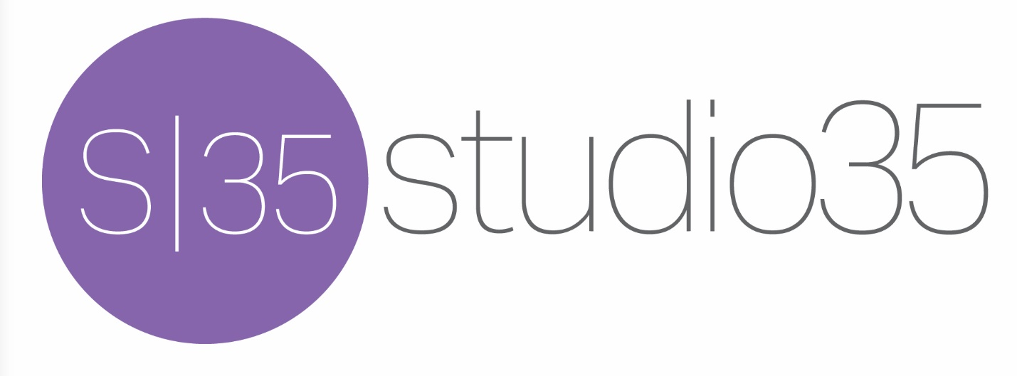
booking@studio35music.com www.studio35music.com

